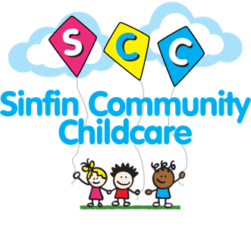

Sinfin Community Childcare - Declaration of Interest for Role of PANco

Name: _________________________ Nursery Site: _________________________
What interested you the most about this opportunity?

Why do you think you would make a good PANco?

What do you feel the PANco role could bring to…
A) Your Nursery Site

B) The Organisation

Anything else you wish to add in support at your application:

Please email your completed declaration to julie@whitehousenurseries.com
All declarations of interest should be returned by: FRIDAY 16th OCTOBER

